Tavistock and Portman Charity | Small Bids Reporting Form
Project title | Coproduction: Team Name Change
Name of successful applicant/ team | -

Please describe the lasting impact of this funding and who has benefitted (500 words).
We hugely appreciate the support from Tavistock and Portman Charity which enabled us to develop a new name and logo for the service and to hold a catered event to mark the official change in the teams name based on a co-production project with 5 young people who have experience of using the service.

It is thought the name change will have impact on the young people who were involved in the project (see testimonials below) giving them an experience of having their voice heard and meaningfully shaping a service they use. More widely we believe the name changes has updated the service to reflect contemporary view of terminology for children in the care system as the previous name was outdated and not inline with national changes. This is to make the service more appealing and ultimately more accessible for young people who may benefit from CAMHS support and are children looked after.

We believe it also contributes to the growing movement of meaningful co-production and we have presented our work internally at the Tavistock and Portman Trust and externally to NCL senior leadership partners and members of the executive board.

Please provide us with any pictures or testimonials that can be shared.
Clinical members of the team worked successfully with young people/coproduction partners to run focus groups, develop and evaluate a survey and ultimately create a new name and logo for the service.

You people involved reported feeling valued and their voices heard, it was also valuable work experience for some of our young people who are seeking work.
Professionals, senior leadership and service users all feed back positively on the new name and logo.

Dissemination of this change was marked with a catered launch event where certificates were given to the young people, senior leadership from Camden local authority and Tavistock and Portman were present. Communications from both Camden local authority and Tavistock and Portman published on this event.

The logo and name now appear on our NCL waiting room website, letterhead, email signatures etc.
NEW LOGO AND NAME
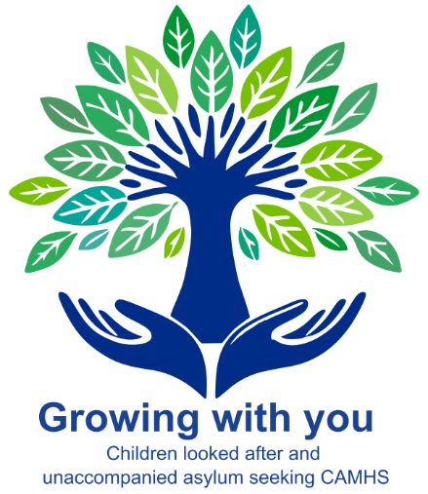

IMAGES FROM OFFICIAL LAUNCH
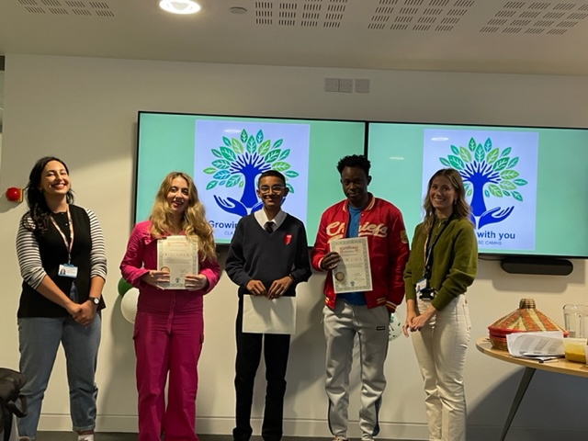

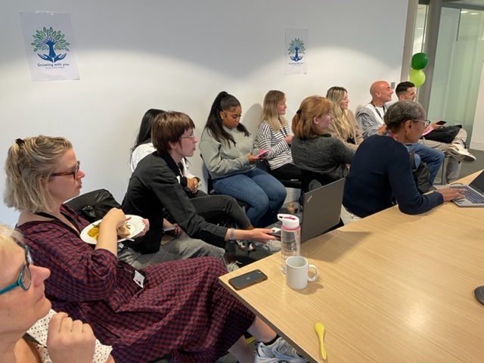
TEXT FROM CAMDEN COMMUNICATIONS (Thursday 12th September, 2024)
Growing With You – new name for specialist CAMHS service
Growing With You has been chosen as the new name for a specialist child and adolescent mental health service (CAMHS) following a project involving young people.
On Wednesday (11 September), Camden CAMHS Children Looked After and Unaccompanied Asylum Seekers Teams celebrated a co-production project they have been running with young people to change their team’s name and logo. The full-length new name of the service will be:
Growing with you: CAMHS Children Looked After and Unaccompanied Asylum Seekers Team.
Add logo image
Attendees came together at 5 Pancras Square to enjoy the reveal, accompanied by a short presentation about the project, speeches, and refreshments.
During the presentation, the team discussed the reasons for the name change, the importance of co-production with young people in the name and logo change, and the methodology they used.
“We wanted a name and logo that felt meaningful and encapsulated the voices of service users.”
To ensure co-production, the team facilitated several after-school meetings with a small group of young people, and they also conducted a wider focus group with additional young people and partners. There was also a survey sent out, which received over 30 responses and reflected a wide group, including carers, social workers, CAMHS professionals, and young people.
After much deliberation, Growing with you: CAMHS Children Looked After and Unaccompanied Asylum Seekers Team was agreed upon. One young person who was part of the decision-making said:
“It shows collectiveness, unity, love, and inclusivity.”
Attendees also heard the co-producers, who spoke about their experience of the project and what the new name and logo mean to them. Both Kedir and Asim spoke about their experience of the project.
Kedir said:
“The project has made me happy. One thing I love about the team is that it gives space to grow.
“I love the new name; it brings people together and represents shared ideas.”
Asim also commented on the logo and name:
“The hands symbolise working together, and the tree is us growing together from the root.
“The name means someone by your side until you are an adult.”
The event ended with all the co-producers receiving certificates and thanks being given to everyone involved in this amazing co-production project with service users.
Find out more about the team.

